**Chapter-8**

**RESULT**

**8.1 User-End Application**

The below figures show the user-end view of the Easy-Infra application.

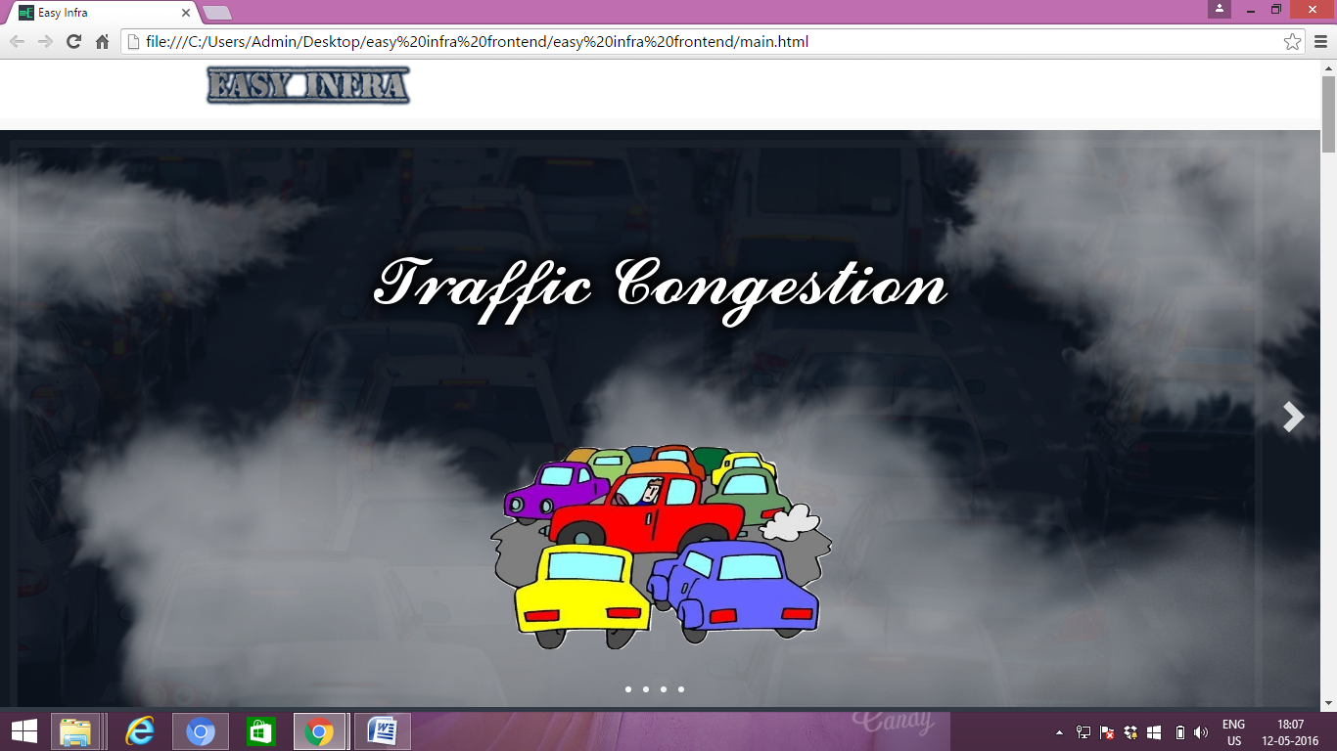

**Figure 8.1**

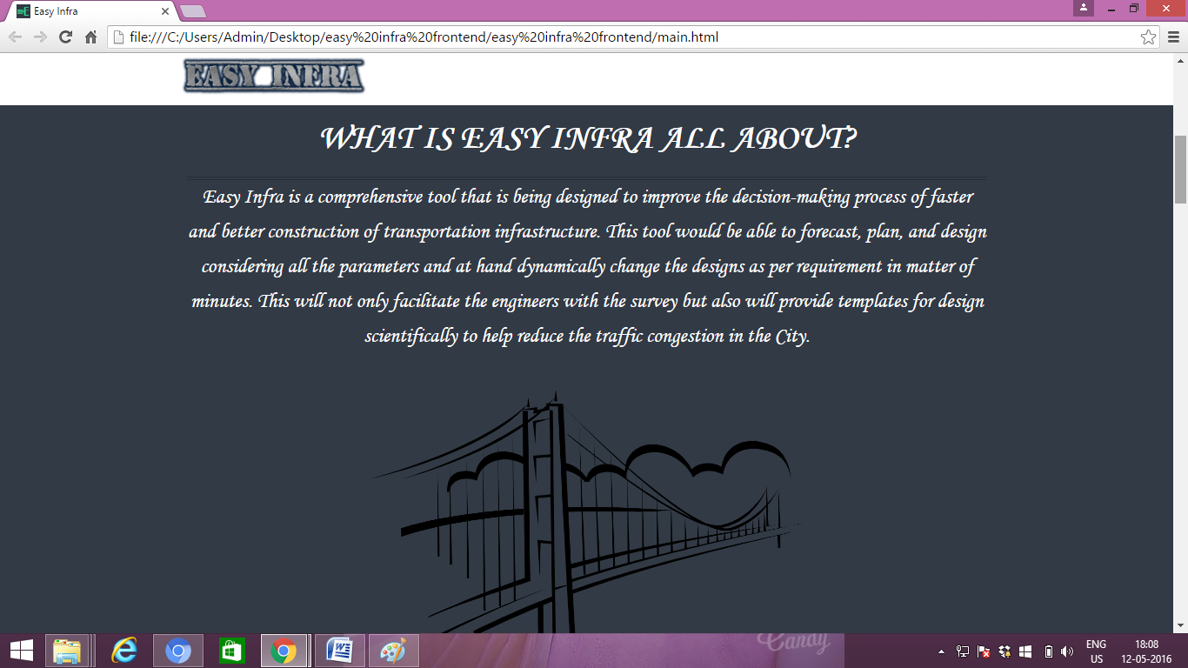

**Figure 8.2**

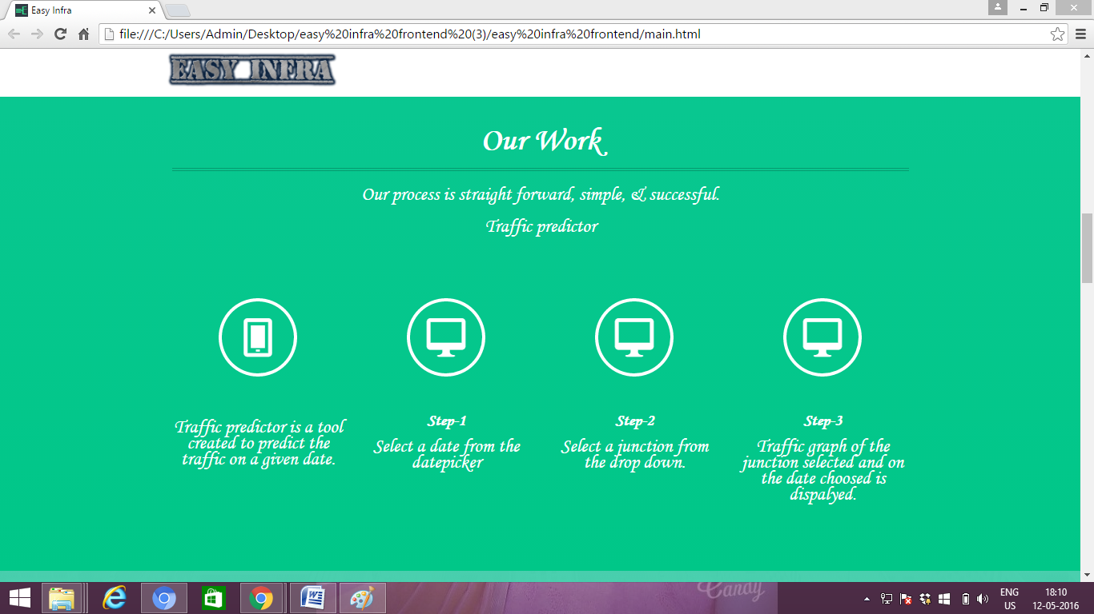

**Figure 8.3**

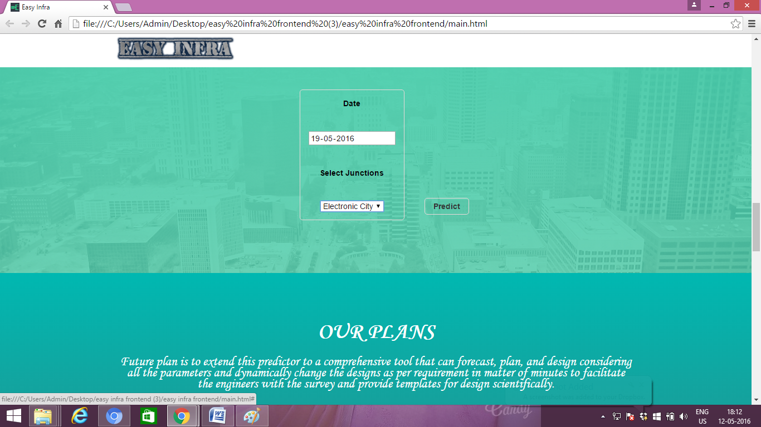

**Figure 8.4**

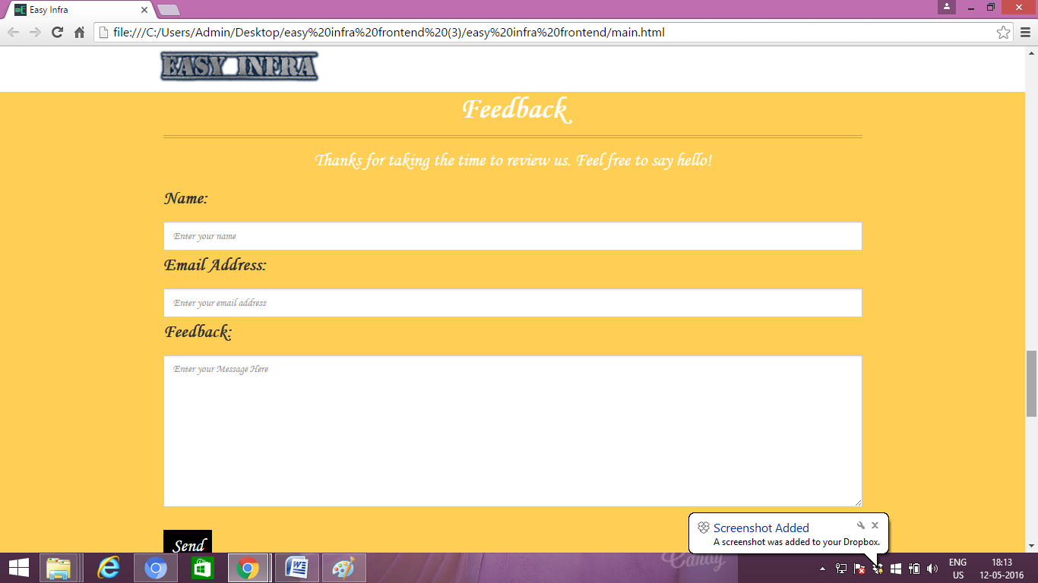

**Figure 8.5**

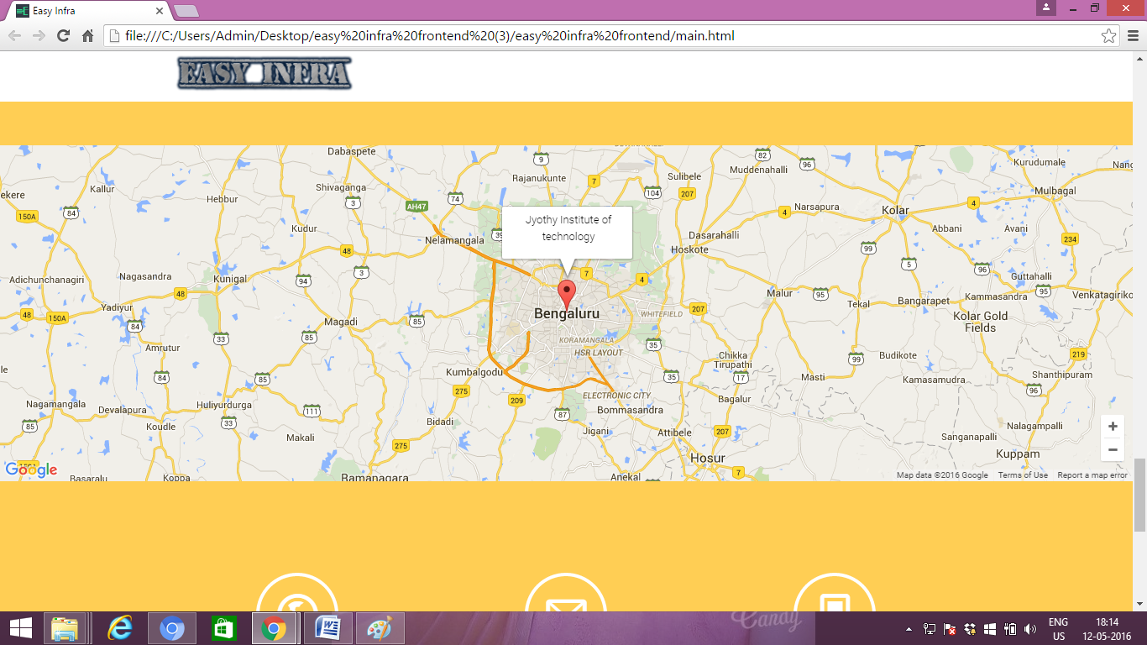

**Figure 8.6**

**8.2 How it works?**

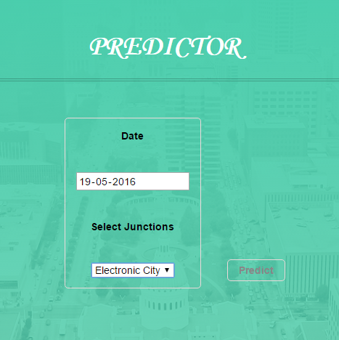

**Figure 8.7: Traffic Predictor**

* User needs to pick a date from the date picker of the predictor section.
* Then select the junction from the dropdown.
* Click on the predict button.
* Google charts plots the graph of the traffic density against the time of the selected future date as shown in Figure 8.8

**Figure 8.7: Traffic Predicted for may 19th 2016**

**8.3 Summary**

This chapter discuss about the application in end-user perspective.